Reginald True

Professor Kayl

CS 340

April 25 2025

1. db.research.find({"name" : "AdventNet"})

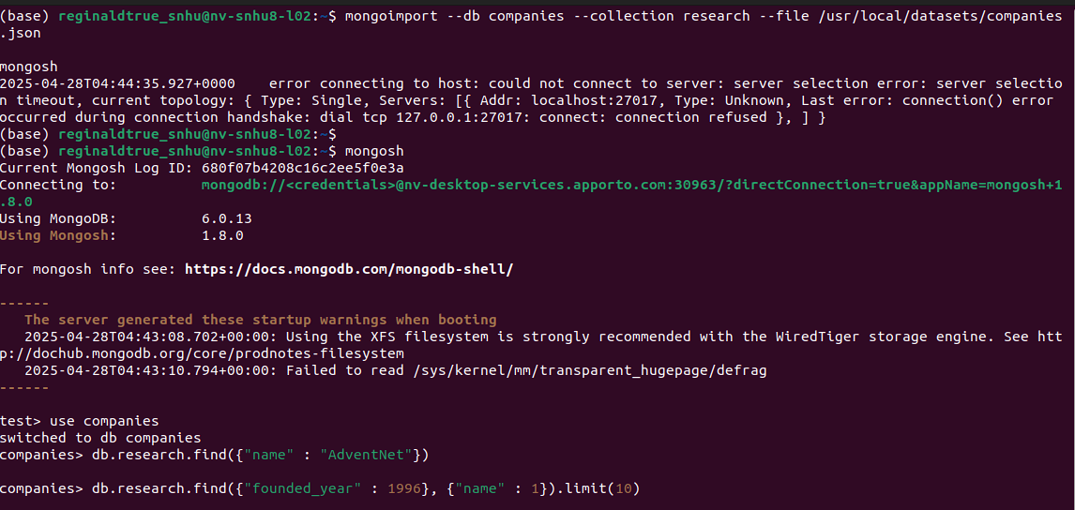2 db.research.find({"founded_year" : 1996},{"name" : 1}).limit(10).

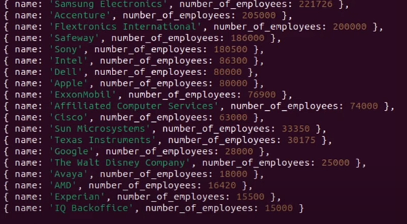

db.research.find( { "offices.state_code": { $in: ["CA", "TX"] } }, { name: 1, number_of_employees: 1, _id: 0 } ).sort( { number_of_employees: -1 } ).limit(20)

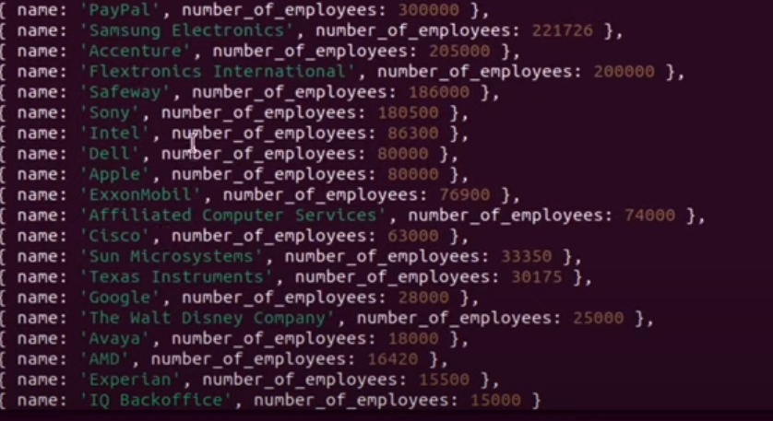

db.research.aggregate([ { $unwind: "$offices" }, { $match: { "offices.country_code": "USA" } }, { $group: { _id: "$offices.state_code", totalOffices: { $sum: 1 } } }, { $sort: { "_id": 1 } } ])

